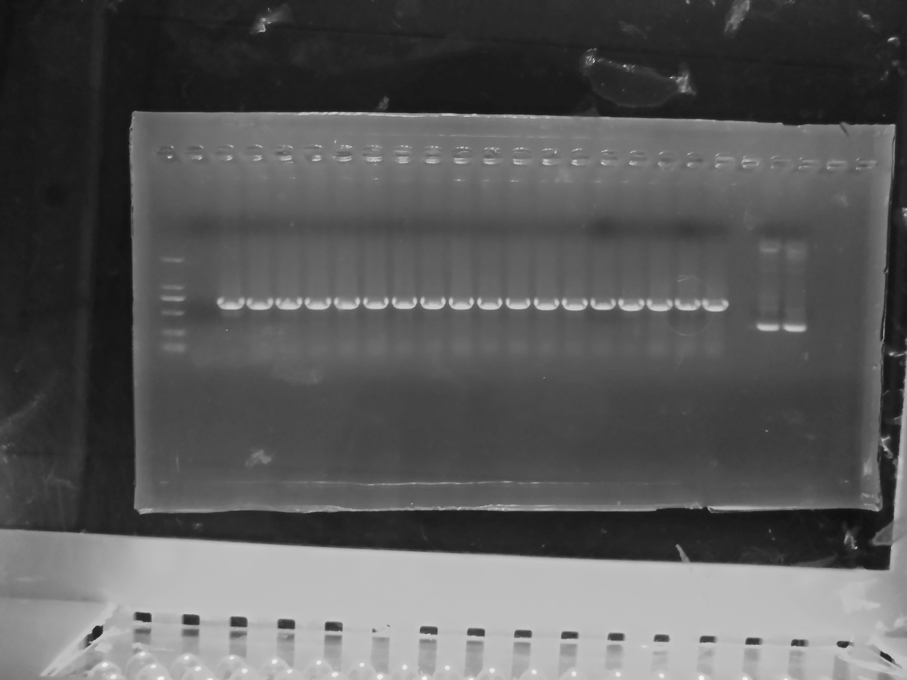
bp

2000

1000
750
500
250
100
M 1 2 3 4 5 6 7 8
apr

Figure S5. PCR analysis of apramycin (ap^{r}) gene from recombinant strains S. rimosus M527-NA_{sr}. DL DNA 2000 marker was used (M). Lane 1: PCR product of ap^{r} gene from S. rimosus M527; lane 2-8: PCR product of ap^{r} gene from recombinant strains S. rimosus M527-NA_{sr}.

